Part 1:

Watching a flock of birds in nature is a captivating experience. The flock of birds – usually made up of hundreds of birds – can fly as one unit, change direction in a fluid motion, and yet never collide into one another (Lorek & White, 1993). A flock of birds also avoid obstacles at any speed and without much difficulty. If the flock of birds were to split (e.g. avoid a predator) the birds will immediately form two or more smaller flocks. To be able to simulate this flocking behaviour, with the inclusion of a predator, on a computer it is a much more difficult and complex task.

To simulate the flocking behaviour, I built upon the pre-existing flocking library that NetLogo provides (Wilensky, 1998). The library has three main goals: alignment, separation, and cohesion. Alignment is the idea that when a bird turns, it turns in the same direction that nearby birds are turning. This reflects the real-life simulation that a flock of birds change direction in a fluid motion. Separation is the idea that a bird will turn to avoid an obstacle (e.g. another bird, predator, etc.) which get too close. Lastly, cohesion is the idea that a bird will move towards other nearby birds. This is to maintain the flock appearance that is shown in real-life, even when the flock is split, the birds will still form flocks – just smaller ones.

To extend on from this library, I added additional functionality to the birds and added a predator(s) to the flocking simulation. The birds have an additional separation function which I named ‘avoid predator’. This function was included so that the birds register the predator(s) and can avoid the predator sooner and with greater space than they would have from avoiding another bird. In real life birds can detect small motions or tiny details with their eyesight and are often assisted with their other senses to avoid a predator (Mayntz, 2019). To avoid the predator, I have made the birds fly to the nearest centre of their flock. Maintaining large flocks is a defence mechanism – as there is safety in numbers – to deter the predators away (Mayntz, 2019). I believe this behaviour is different from the separation function used in the library and is the reason I added it in so that it illustrates what happens in real life.

The predator the following properties: vision, attention span, turning radius, and speed. Vision was included to determine how far the predator can see the birds. I added this as a slider so that users can see how the variance in predator vision would affect the flocking behaviour of the birds. I also added a slider for the predator’s attention span. In real life when birds are in flocks, predators will easily lose focus of an individual bird and just aim to catch any nearby bird. The turning radius of the predator was added as a slider so that when a predator turns, it is doing so in a realistic manner. Finally, the speed of a predator can be adjusted. These predator properties were added so that they depict real life predators, as different predators have different strengths and weaknesses when hunting prey.

In my code, the predator was named hawk and had two main functions: hunt and lose interest. The hunt function is the idea that the hawk will head to the nearest bird in its vision radius. The lose interest function is the idea that the hawk will lose interest in an individual bird and will randomly choose another bird within its vision radius. I believe that these two functions depict the main qualities of a predator when they are hunting prey in flocks.

To use the system first load the model into NetLogo. The model is located under Part 1 in the folder structure, named “Flocking_with_hawk”.

Once you load the model into NetLogo, there is a lot of settings you can change (refer to Table 1). I have split the settings into two sections for convenience – birds and hawks. Birds settings change all the properties linked to the bird and the hawk settings change the hawk’s properties. All the properties are on sliders which makes it easier to change the values. There is one exception which is hawks kill. This is a switch that changes whether a hawk can kill a bird or not.

There are four graphs on the model. The large one to the right is a combination of the three graphs at the bottom. Once you have setup the properties for the birds and hawk(s) that you want, press the setup button and then the go button to start the simulation. The graphs will automatically record as the simulation is taking place.

Table 1 Parameters and their descriptions for the model.

|  |  |
| --- | --- |
| Parameter | Description |
| Bird population | Amount of birds simulated |
| Bird see bird distance | How far a bird can see |
| Minimum separation birds | How close one bird can get to another |
| Max align turn | Maximum turn angle to align with other birds |
| Max cohere turn | Maximum turn angle to cohere with other birds |
| Max separate turn | Maximum turn angle to separate from other birds |
| Turn away from hawk | Maximum angle birds can turn away from hawk |
| Birds see hawk distance | How far a bird can see a hawk |
| Bird Speed | How fast birds are |
| Hawk population | Amount of Hawks simulated |
| Loose interest | Chance of Hawks loosing interest in a bird |
| Max hawk turn | Maximum turn angle a hawk has |
| Hawk see bird distance | How far a hawk can see a bird away from |
| Hawk speed | How fast hawks are |
| Hawk kills bird | If hawks kill birds or not |

Testing and assessment were conducted on a population of 500 birds and 0-1 hawk. Table 2 shows the bird and hawk settings for the testing and assessment. The bird settings were used to depict the natural flocking formation that is formed in real life simulation (refer to Figure 1). One hawk was used in the testing and assessment since predators typically hunt prey by themselves.

Table Bird and hawk settings for the testing and assessment

|  |  |
| --- | --- |
| Parameter | Value |
| Bird population | 500 birds |
| Bird see bird distance | 5 patches |
| Minimum separation birds | 0.5 patches |
| Max align turn | 20 degrees |
| Max cohere turn | 3 degrees |
| Max separate turn | 1.5 degrees |
| Turn away from hawk | 30 degrees |
| Birds see hawk distance | 20 patches |
| Bird Speed | 0.2 |
| Hawk population | 0 or 1 hawks |
| Loose interest | 60% chance |
| Max hawk turn | 20 degrees |
| Hawk see bird distance | 30 patches |
| Hawk speed | 0.26 |
| Hawk kills bird | True or False |

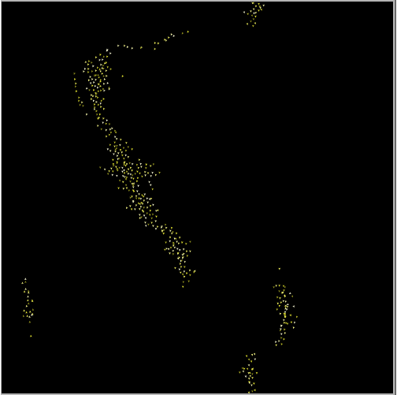

Figure 1 Birds Flocking visualisation

To test and assess the flock formation, I assessed how the average flock size is maintained in the simulation. Figure 2 shows the average flock size when a hawk is not present. The fluctuations in average flock size highlight that in real life there can be obstacles (e.g. powerlines, trees, buildings, etc.) that flocks of birds will have to avoid but is generally stable. This means that the birds may separate and form smaller flocks for a short period of time, but they will all come back together after a while. Once a hawk is introduced, the fluctuations are more pronounced (refer to Figure 3). The birds will try to maintain bigger flocks to scare off the predator (Figure 4). But the birds will also have to separate more regularly depending on how many times the predator attacks. Figure 3 depicts the fluctuations in average flock size when the hawk is not killing any birds. Whereas Figure 5 shows the downward trend that the average flock size will have if birds are getting killed by the hawk. Whilst this was interesting to look at, in real life if a predator was to kill a bird, they would typically take the bird and eat it. This generally means that the rest of the flock of birds has time to escape and therefore this downward trend is unlikely to occur.

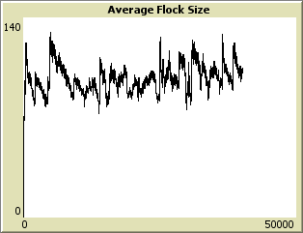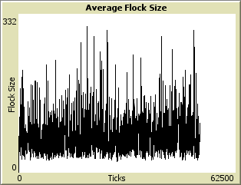

Figure Average flock size, with no hawk present

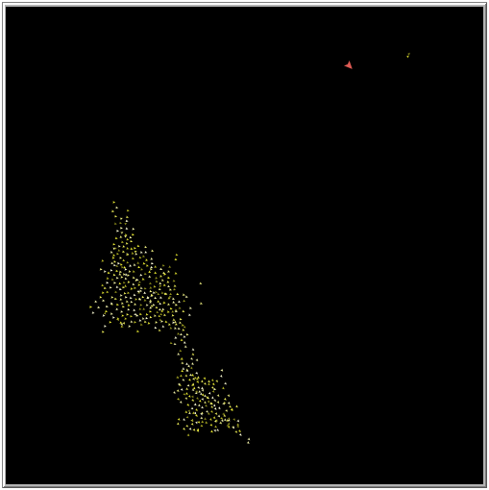

Figure 4 Birds flocking visualisation with hawk present.

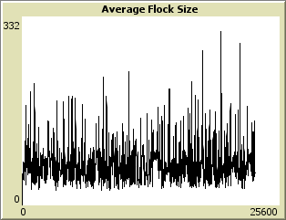

Figure 3 Average flock size, with hawk present

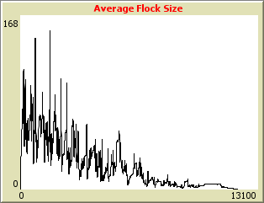

Figure 5 average flock size with hawk present and can kill the birds

**References**

Lorek, H. and White, M., (1993). Parallel bird flocking simulation. Parallel Processing for Graphics and Scientific Visualization.

Mayntz, M. (2019). Bird Senses and How They Use Them, The Spruce, viewed 14 April 2020, <https://www.thespruce.com/birds-five-senses-386441>

Wilensky, U. (1998). NetLogo Flocking model, Center for Connected Learning and Computer-based Modelling, Northwestern University, Evanston, viewed 10 April 2020, [http://ccl.northwestern.edu/netlogo/models/Flocking.](http://ccl.northwestern.edu/netlogo/models/Flocking)